Don’t Trust Anyone !!



Designer: Chaocheng Lin

* OVERVIEW
  + You and your new friends wake up in the old, large and horrible house. You and your new friends hear a strong voice. The voice said, “This house will disappear at 6:00a.m. If you cannot leave the house, you will become one of us. HAHAHA!”
  + You look at your watch. “Oh! You Only have 10 hours to escape.”
* GOAL
  + Escape the house as soon as you can.
* NUMBER OF PLAYER: 2-6
* Playing time: 30-60 Min
* Age: 12+
* CONTENTS:
  + Dice x 1
  + House Map x 1
  + Tool Card x 36
  + ID Card x 6
  + Wet Token x 7
  + Oil Token x 7
  + Collapsed Token x 7
  + Status Card x 12
  + Index Page x1
  + Script Book x 1
* PRE- GAME SETUP
  + Each player draws 1 ID card.
  + Put Status card on the House Map
  + See who goes first. The player who has the next birthday goes first. Players take turns clockwise following the first player.
* GAME-PLAY
  + Starting with the first player, the current player does the following actions in the order listed below, after which it is the next player’s turn, and so on and so forth.
  + First, we’ll give you a brief description of the actions you have to do during one of your turns.

**Searching**

Explore the room

Check the script

and follow it.

**Using**

Use the tool

Check the script

and follow it.

Start

* Special – Trade/Share information
  + Each player can trade tools to the other player.
  + Each player can share information to the other player.
* Special – Searching
  + Only the house which has eye icon can search the tools.
  + Roll the dice.
    1. If the [die’s point]>=4, you can draw a tool card which belongs that room.
    2. If the [die’s point] = 6, you can choose a tool from that room.
* Special – Using
  + The players choose the tool from their hand and check the index page.
* Special – Index page/Script book
  + Check the script book from top to bottom.
* End of the game
  + The first player who leave the house is the winner before 10 rounds.
  + If no one leave the house before 10 rounds, there is no winner.



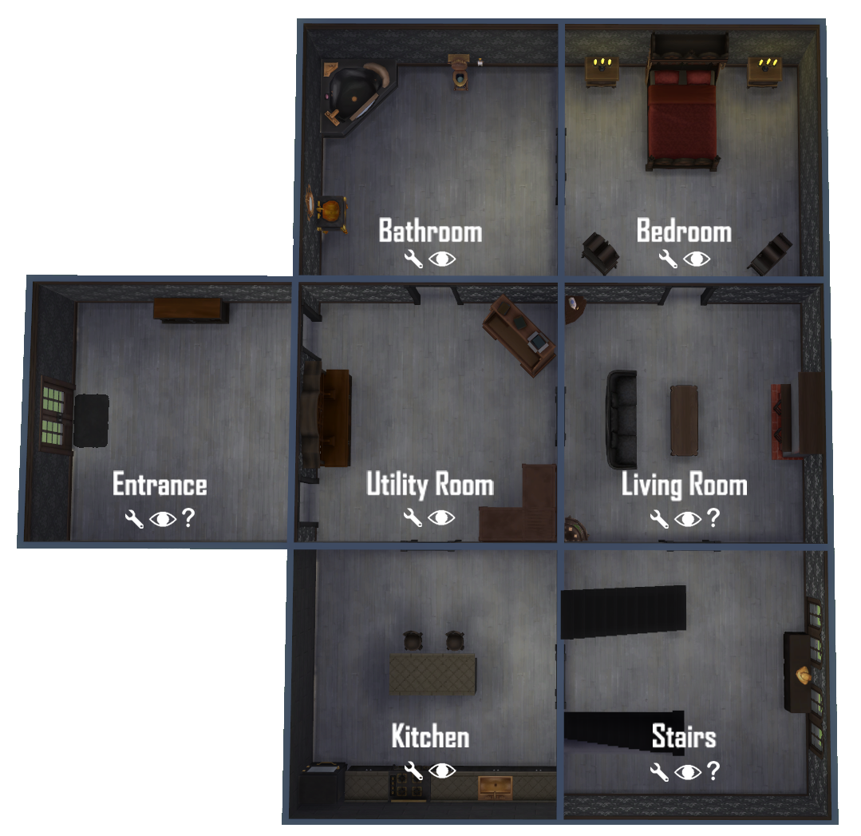**House Map**

 **: Using tool in this room.**

 **: Searching tools in this room**

 **: Wired status in this room.**

**ID card**

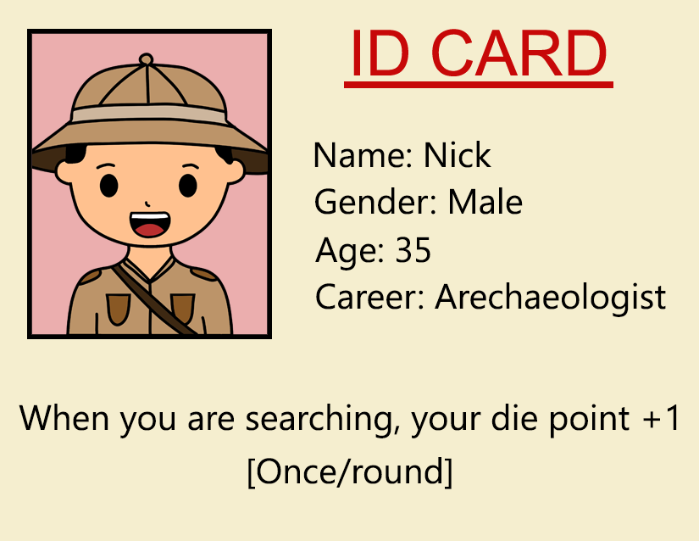

**Tool card Status card**

